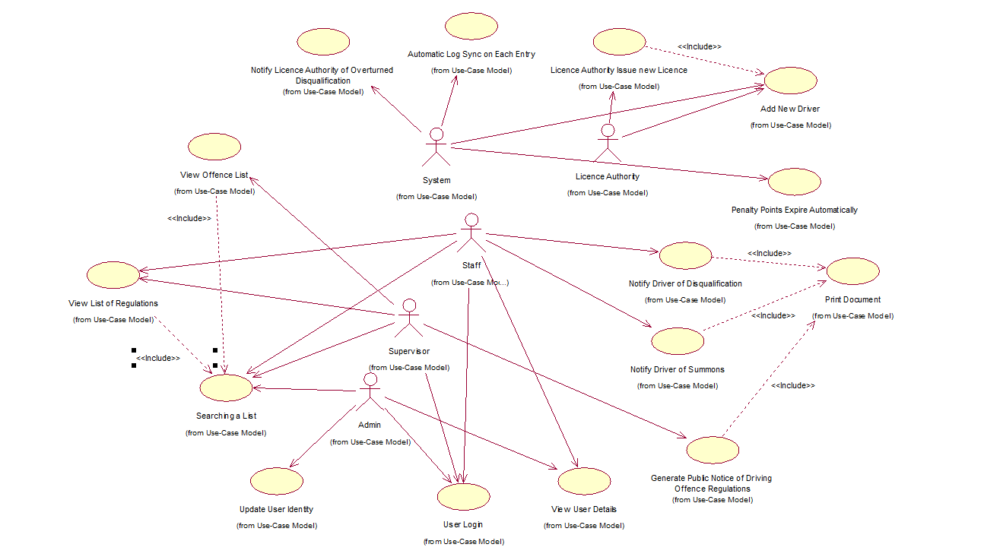

### View List of Regulations

**Participating Actor:** Supervisor

**Entry Conditions:**

This use case both acts standalone and is invoked by related use cases. The Supervisor must inspect the List of Regulations. The Supervisor invokes the View List of Regulations function.

**Flow of Events:**

1. The System presents a list, which has been prepopulated with the details of existing regulations, and presents blank spaces to enter new records. The system does not display records referring the Regulations that have a Termination Date field which is not null. The system displays the following information for all current and future effective regulations:
   1. A short Definition of the regulation.
   2. The Amended Regulation ID referring to a regulation which has been amended. This field must either be blank or a valid id.
   3. The Publishing Date of the new Regulation.
   4. The Effective Date upon which the new Regulation will take effect.
   5. The Number of Penalty Points upon payment of a fine prior to a court summons.
   6. The Number of Penalty Points upon conviction.
   7. The Amount Payable prior to an appearance in court.
   8. The Amount Payable upon conviction.
   9. A checkbox indicating that the offence requires a Mandatory Court Appearance.
2. The Supervisor inspects the information.

**Exit Conditions:**

The list of regulations have been viewed.

### User Login

**Participating Actor:** A User

**Entry Conditions:**

Under no circumstances are passwords to be stored in the database. To access the system a one way MD5 hashing algorithm is used to transform the User ID and Password combination into a Cipher. The Cipher must match the one recorded in the database.

Users have at most three attempts to enter a password correctly.

A user wishes to access the system and the User Login function has been invoked.

**Flow of Events:**

1. The System responds by presenting blank fields requesting the following information:
   1. User ID
   2. Password

And the system presents the following options to “Submit” or "Cancel”

1. The User enters their User ID and Password and submits the information.
2. The system first logs the event, then checks if the User ID has been deactivated and if so the system proceeds to step 7 below.
3. Otherwise the system appends the Password to the end of the User ID and passes the concatenated string into an MD5 hashing function to produce a 256bit Cipher. The system users the plaintext User ID to acquire the associated Cipher stored in the database.
4. If the Cipher acquired from the user matches the Cipher recorded in the database then the user is assumed to have provided the correct credentials. The system grants the user access to the System. The system retrieves the appropriate Black List and White List Rules from the Access Control system and execution proceeds by invoking the View User Inbox Use Case.
5. If the Ciphers do not match then the system logs the event and counts the number of failed attempts and presents the user with a message stating that the user ID or password are incorrect and that they have n attempts remaining. If the count:
   1. Is less than three attempts, the system displays a Forgot Password button, which when pressed invokes the Forgot Password Use Case, and the system proceeds to step 1 above.
   2. Is equal to three attempt, the system deactivates the user account
6. The system notifies the User that the account has been deactivated, and informs the User to contact the administrator to reactivate the account. The system exits when the User closes this Message.

### View User Details

**Participating Actor:** Admin, Or the User that this account represents

**Entry Conditions:**

An admin wishes to view the recorded details associated with a user.

The admin has invoked the “View User Details” function.

**Flow of Events:**

1. The System displays a read only form containing the following:
   1. The **Organisation ID** which is defaulted to PP for Penalty Points Bureau

All possible choices are:

* + - PP for Penalty Point Bureau
    - LA for Licence Authority
    - GS for Gardaí *Síochána*
  1. The **User ID**.
  2. User Role which is a list containing Admin, Supervisor, Staff, Speed Camera, but is not limited to these choices and can be defined as needed.
  3. The **Date Added**.
  4. The **Date Revoked**.

And If the User is an employee of the Penalty Points Bureau:

* 1. the First Name
  2. the Last Name(s)
  3. Email Address
  4. Home Address
  5. Telephone Number

**Exit Conditions:**

The system has displayed the details recorded in the users account.

### Update User Identity

**Participating Actor:** Admin

**Entry Conditions:**

An admin must update a change of details for an employee of the Penalty Points bureau.

The admin has invoked the “update user Identity” function.

**Flow of Events:**

1. The System display a list of all user identities and presents the following:
   1. The **User ID**.
   2. First Name
   3. Last Name(s)
   4. Email Address
   5. Home Address.
   6. Telephone Number
2. The admin enters the new information into the fields provided.
3. The system detects that a row is being edited and presents a Bright Green Apply button and a slightly darker red Reset button.
4. The admin continues to enter the new information and click the:
   1. Green Apply Button.
   2. Red Reset Button.
5. The system responds by:
   1. In the case of Apply by displaying the Confirm Update Identity message.
   2. In the case of Reset by resetting the edited fields to their previous state. Then proceeds to step 1 above.
6. The admin inspects the information and confirms.
7. The system updates the fields and displays a confirmation by displaying a green tick next to the updated row and sets the status text to “identity updated successfully”

**Exit Conditions:**

The admin has updated the systems records for the employee.

### Licence Authority Issue new Licence---Colin

**Participating Actor:** Licence Authority

**Entry Conditions:**

The Motor Licence Authority System must notify the Penalty Points Bureau of any Licences they issue, or any change of details they record to a driver’s name, address, or class of Licence held (Learner Permit or Full Drivers Licence). The Motor Licence Authority System has registered such a change and has invoked the Licence Authority Issue Licence function.

**Flow of Events:**

1. The System displays a prepopulated list of the Licence Record which includes the following information for each licence recorded:
   1. Licence No.
   2. A checkbox indicating that the Licence is a Learner Permit.
   3. Date Licence was Issue.
   4. Licence Expiry Date.
   5. Drivers First Name.
   6. Drivers Last Name(s).
   7. Drivers Address.
   8. Drivers Date of Birth.
2. The Licence Authority enters the details and submits.
3. The System requests confirmation and presents the submitted information for review.
4. The Licence Authority verify that the details are correct and confirm.
5. The system records the changes and displays a message stating that the changes where applied successfully. The system returns to the inbox.

**Exit Conditions:**

The Motor Licence Authority have been notified of the Penalty Points Bureau of the newly issued licence or change to drivers details.

### Notify Licence Authority of Overturned Disqualification---Colin

**Participating Actor:** The System

**Entry Conditions:**

The System must notify the Licence Authority of a list of Disqualifications which have been overturned as part of an appeal. The System has invoked the Notify Licence Authority of Overturned Disqualifications function.

**Flow of Events:**

1. The System displays a prepopulated list of Disqualifications which have been overturned and not yet notified to the Licence Authority. The list includes the following for each of the Disqualifications:
   1. Licence No.
   2. Date of Disqualification.
   3. Expiry Date Disqualification. Set to the date of the Court Ruling (in the past)
2. The System selects a Disqualification from the List.
3. The System notifies the Licence Authority of the Disqualification has been overturned by transmitting the information above.
4. If there are more Disqualifications to be overturned. By proceeding to step 1 above.
5. Otherwise the system exits.

**Exit Conditions:**

The Motor Licence Authority have been notified of the Disqualification.

### Add New Driver

**Participating Actor:** Licence Authority System

**Entry Conditions:**

A new list of newly issued driving licences have been received from the Licence Authority and must be added to the system.

The Add New Driver function of the system has been invoked.

**Flow of Events:**

1. The system responds by presenting the “Add New Driver” form which requests the following information:
   1. Licence Number – Required, and generated by the Licence Authority system.
   2. First Name – Required.
   3. Last Name – Required.
   4. Date of Birth – Required.
   5. Address Line 1 – Required.
   6. Address Line 2 – Optional.
   7. Address Line 3 – Optional.
   8. County ID – Required, and must be selected from a predefined list
2. The Licence Authority enters the details and submits the information.
3. The system responds by displaying the “Confirm New Driver Details” screen, which displays the information entered and asks for confirmation that the information is correct.
4. The Licence Authority inspects that the information was entered correctly and presses submit.
5. The system responds by displaying a confirmation screen declaring that the new drivers’ details have been added to the system. The system also presents the user with the option to enter details for another new driver.
6. The Licence Authority presses:
   1. Yes, if they need to add another new driver to the system.
   2. No, if they have added all the details of each new driver.
7. The System responds by:
   1. In the case that the user selected Yes, by proceeding to step 1 above.
   2. In the case that the user selected No, by presenting the user with a list of all the newly added drivers’ details.

**Exit Conditions:**

The list of new drivers has had their details added to the system.

### View Offence List

**Participating Actor:** Supervisor

**Entry Conditions:**

This use case both acts standalone and is invoked by related use cases. The Supervisor must inspect the List of Offences. The Supervisor invokes the View List of Offences function.

**Flow of Events:**

1. The System presents a list, which has been pre-populated with the details of offences, and presents a search bar and the ability to sort based on attributes, there is also button to allow functionality such as add, edit and archive. The system displays the following information of offences:
   * + Offence No.
     + Driver No.
     + Regulation ID.
     + Location.
     + Date of Recording.
2. The Supervisor inspects the information.

**Exit Conditions:**

The list of regulations have been viewed.

### Notify Driver of Summons

**Participating Actor:** Staff

**Entry Conditions:**

This action is governed by the Data Protection Acts 1988 and 2003. Staff members must sign a Non-Disclosure Agreement before being exposed to any sensitive information.

Members of Staff has received notifications of newly Reported Summons. The member of Staff must issue a Notice of Summons and has invoked the Notify Driver of Summons function.

**Flow of Events:**

1. The System acquires and displays the following information associated with the Offence:
   1. The Reference No of the Offence.
   2. The Time and Date of the incident.
   3. The Location at which the incident occurred.
   4. The Drivers Licence Number.
   5. The Vehicle Registration.
2. The member of Staff presses the Notify Driver button.
3. The System responds by generating a Letter of Notification of Summons which must include the following information:
   1. The Name and Address of the Driver positioned to fit in a windowed envelope.
   2. The Drivers Licence Number.
   3. The Reference No of the Offence, both in numeric form and as a Bar Code.
   4. The Time, Date and Location at which the incident occurred.
   5. The Section and Act (Section 5 of the Road Traffic Act 2002).
   6. The Description of the Regulated Offence.
   7. Date and Location of the Court Hearing.
   8. The Number of Penalty Points to be endorsed as defined by the Regulation.
   9. The Amount Payable and a Payment Deadline of 28 days from the current date.
   10. Instructions on how to make payments at a local Post Office Branch.
   11. Contact Details for the Penalty Points Bureau to facilitate enquiries.
4. The member of Staff presses the Print button.
5. The System responds by printing the Letter of Notification of Summons. The System also records the Notification in the Database. The System returns to the Inbox.

**Exit Conditions:**

The Notification of Summons has been recorded in the Database.

The Letter of Notification of Summons has been printed and is ready to be sent by Registered Post

### Generate Public Notice of Driving Offence Regulations

**Participating Actor:** Supervisor

**Entry Conditions:**

The Regulations have recently been amended and the Supervisor needs a copy of the regulated lists. The Supervisor invokes the Generate Public Notice of Driving Offence Regulations functions.

**Flow of Events:**

1. The System presents a list containing the following information for all effective regulations:
   1. A description of the offence.
   2. The number of Penalty Points upon being charged.
   3. The number of Penalty Points upon being convicted.
   4. The amount payable upon being charged (labelled as Paid in first 28 days).
   5. The amount payable on conviction.
   6. And in the case where a mandatory court appearance is required the system displays an “*” character in the fields b and d of this list.
   7. Where applicable an amount payable is specified as “Court Fine”
   8. At the end of the list the system displays a message stating “* = mandatory court appearance”
2. The Supervisor presses the Print button.
3. The system records the report and invokes the Print Document Use Case.

**Exit Conditions:**

The Supervisor has created a report of all effective regulations.

### 

### Automatic Log Sync on Each Entry

**Participating Actor:** The System

**Entry Conditions:**

An access to the database has been issued and the Add a Log Entry function has been invoked automatically.

The system has been given a log entry and the entry must be synchronized to the master log.

**Flow of Events:**

1. The System has records the entry in the local log file.
2. The System records the entry in the remote database log table.

**Exit Conditions:**

The event has been logged to the local log file.

The event has also been recorded in the master log file.

### Searching a List

**Participating Actor:** User

**Entry Conditions:**

A user wishes to search a list and show only relevant results.

**Flow of Events:**

1. The System presents a search box which accepts regular expressions.
2. The User enters text in the search box.
3. The System detects that the search box has changed and uses the text to pattern match the fields in the list being presented. Each record in the list that matches the pattern is made visible, all the other records in the list are hidden.
4. The user continues to enter text until the list has been narrowed down considerably.
5. The system presents the final list of all matches.

**Exit Conditions:**

The list has been narrowed down to only relevant entries.